

MINUTES OF THE LPAC MEETING
Today’s Youth Future Jobs Project
PAC DATE: 13 February 2023
PROJECT NAME: Today’s Youth Future Jobs
IMPLEMENTING PARTNER: Union of Municipalities of Turkey
START DATE: 01 March 2023
END DATE: 28 February 2027
TOTAL RESOURCES:
-TRAC (AMOUNT): USD 0
-DONOR (NAME AND AMOUNT): European Union, USD 8,412,710.00
-GOVERNMENT (NAME AND AMOUNT): NA
-IN KIND (NAME AND AMOUNT): NA
-GMS (RATE AND AMOUNT): USD 550,364.21
CONTRIBUTING OUTCOME: UNSDCF Programme Results and Resource Framework Outcome: By 2025, public institutions and private sector contribute to a more inclusive, sustainable, and innovative industrial and agricultural development, and equal and decent work opportunities for all, in cooperation with the social partners.
UNDP Strategic Plan Outputs: To strengthen human capital of Türkiye by building digital capacity for gender-equal future professions.
Outcome 1: To upgrade and improve the skills of youth and adolescents to play active role in digitalisation and innovations, technological and economic changes.
Outcome 2: To upgrade the capacities of Municipalities/Local Administrations and CSOs in Türkiye on digital skills development and job transition.
INDICATIVE OUTPUTS:
Output 1: Design and operationalization of the Digi Youth Vocational Educational Training Centres are completed.
Output 2: Capacities of youth, adolescents and their awareness on employment opportunities improved.
Output 3: Capacity development for municipalities, local authorities and CSOs completed.
BRIEF INFORMATION ON THE PROJECT:
Unemployment, especially youth unemployment is one of the key economic problems in Türkiye. According to the TURKSTAT Türkiye’s unemployment rate for 2021 was 13.39%, 0.28% higher than the 2020 figures. The unemployment rate for 2020 was 13.11%, which is slightly lower than its 2019 level of 13.67%. Being a result of long-standing structural problems in Türkiye, youth unemployment has been deepened due to limited access to decent jobs due to the pandemic. Youth unemployment is increasing, and on the other hand the lack of motivation and discouragement to look for jobs has been growing among youth (discouraged workers). According to the TURKSTAT the unemployment rate in the 15-24 age group was 20% in April 2022. The youth unemployment rate was estimated at 23,7 percent for women and 18,1 percent for men.
One of the factors of low youth employment and education is assessed to be the limited access to adequate/demand-based professions in Türkiye. According to the official data of TurkStat, Türkiye has a high rate of early school leavers and young people not in employment, education, or training (NEETs). In 2021, the NEET ratio among the youth population aged 15 to 17 was 9.2%. For the young population aged between 18 and 29, the overall NEET ratio was 37.5%, namely 50.5% among young women and 24.4% among young men. The covid-19 crisis has led to the gradual increase of the unemployment rate among the young population as statistics are indicted above and to the displacement of many young people. The pandemic also showed that e-commerce has grown two to five times faster than before the pandemic.
The overall objective (Impact) of the project is to strengthen human capital of Türkiye gender equally by building digital capacity for future professions. The IT, robotics and coding, e-transformation, digital marketing, and complementary areas such as social innovation, solution oriented and design thinking, etc. will be future skills required for youth and adolescents to create added value products to the technology market.
The specific objectives (outcomes) of the project: First specific objective (Outcome 1) is to upgrade and improve the skills of youth and adolescents to play active role in digitalisation and innovations, technological and economic changes. The second specific objective (Outcome 2) is to upgrade the capacities of Municipalities/Local Administrations and CSOs in Türkiye on digital skills development and job transition.
DISCUSSIONS:
Strategic:
With the UNDP Türkiye CO’s assistance to the line Ministries, NGOs and key stakeholders in 2008 the Human Development Report highlighted Türkiye’s achievements in the area of youth and presented this as a best practice in the global arena. This project is proposed to be signed with UNDP to carry out the activities detailed in the present Description of the Action entitled “Today’s Youth Future Jobs”. It is assumed that with its extensive experience and expertise in the fields of vocational training, job creation, digitalization, Industry 4.0 and innovation, UNDP will play a vital role in the success of the proposed project.
The project will provide technical assistance and capacity building with its TA, Supply components to increase and facilitate increased youth employment in Türkiye. The municipalities have certain duties and authorities to promote employability however municipal VET courses was the outdated classes and employment courses offered by the municipal VET centres, therefore, municipalities should adapt to change as the local politics is shaped by the demand of the private sector and local public. The project will establish a model to sustain effective match employment needs and the skills of the youth.
Relevant:
Unemployment, especially youth unemployment is one of the key economic problems in Türkiye. According to the TURKSTAT Türkiye’s unemployment rate for 2021 was 13.39%, 0.28% higher than the 2020 figures. The unemployment rate for 2020 was 13.11%, which is slightly lower than its 2019 level of 13.67%. Being a result of long-standing structural problems in Türkiye, youth unemployment has been deepened due to limited access to decent jobs due to the pandemic. Youth unemployment is increasing, and on the other hand the lack of motivation and discouragement to look for jobs has been growing among youth (discouraged workers). According to the TURKSTAT the unemployment rate in the 15-24 age group was 20% in April 2022. The youth unemployment rate was estimated at 23,7 percent for women and 18,1 percent for men. One of the factors of low youth employment and education is assessed to be the limited access to adequate/demand-based professions in Türkiye. According to the official data of TurkStat, Türkiye has a high rate of early school leavers and young people not in employment, education, or training (NEETs). In 2021, the NEET ratio among the youth population aged 15 to 17 was 9.2%. For the young population aged between 18 and 29, the overall NEET ratio was 37.5%, namely 50.5% among young women and 24.4% among young men. On the other hand, the covid-19 crisis has led to the gradual increase of the unemployment rate among the young population as statistics are indicted above and to the displacement of many young people. The pandemic also showed that e-commerce has grown two to five times faster than before the pandemic.
The labour market is characterised by low activity rates and the underused labour potential of women and youth. Education is key to addressing these structural deficiencies. And VET needs to be further extended and further streamlined. That there are also shortcomings of digitalization. One of the fundamental challenges of digital transformation is that job creation is starting to lag behind job destruction which is poised to affect youth particularly. Businesses are accelerating the digitalization of work processes, learning, and expansion of remote work, as well as the automation of tasks within an organization. Therefore, to attain the twin goals of decreasing unemployment and increasing the competitiveness of the youth, municipalities have to step in at the forefront of implementing the reinforced employment public policy.
Aligned with the national strategic documents (National Youth Employment Strategy of Turkey (2021-2023), 11th National Development Plan, Digital Turkey Roadmap), the project will provide technical assistance and capacity building with its TA, supply components to increase and facilitate increased youth employment in Türkiye.
Municipality representatives, local authorities and other relevant CSOs will be supported to improve their gender perspectives through training programmes on the topics of gender equality, gender-responsive planning, and service design and delivery; and will be assisted in drafting their multi-year investment and sector plans in line with the principles of gender equality and towards achieving specific targets for women's empowerment in employment.
Social and Environmental Standards:
The project closely relates to environmental and climate issues at the national and local levels. It will improve the technical capacities and quality of information necessary for further progress in the implementation of EU Environment and Climate Change legislation and thus contribute to improved environmental protection and climate action, mainly by creating a low carbon economy future profession based on digitalization and green technologies.
While designing the trainings modules and materials the needs of visually impaired and hearing-impaired individuals will be included. In some of the trainings the sign language services will be provided. To increase awareness and inform the vulnerable groups special communication materials will be designed for visually impaired and hearing-impaired individuals.
As one of the focus target groups of the project, participation of vulnerable groups in project activities will be ensured. The centres’ location, building, arrangement of the laboratories, working spaces will be designed considering the needs of persons with disabilities. Especially, Mobile Digi Youth Centres will be designed with the aim of not only increasing the accessibility of youth in rural areas but also the accessibility of physically impaired persons. Moreover, the centres and the training materials will also be designed considering the needs of the latter group. The centres will be established and operationalised considering the needs of people with disabilities.
Gender mainstreaming will be one of the main cross-cutting themes of the Project. Strengthening of the gender mainstreaming approach will be done through gender-sensitive service delivery planning: Gender-responsive services design and delivery will be introduced as a new dimension in the gender strategy for centres. By this, the creation of the grounds and instruments for more egalitarian resource allocation on gender basis is expected.
Management and Monitoring:
The project management structure has been defined as following:
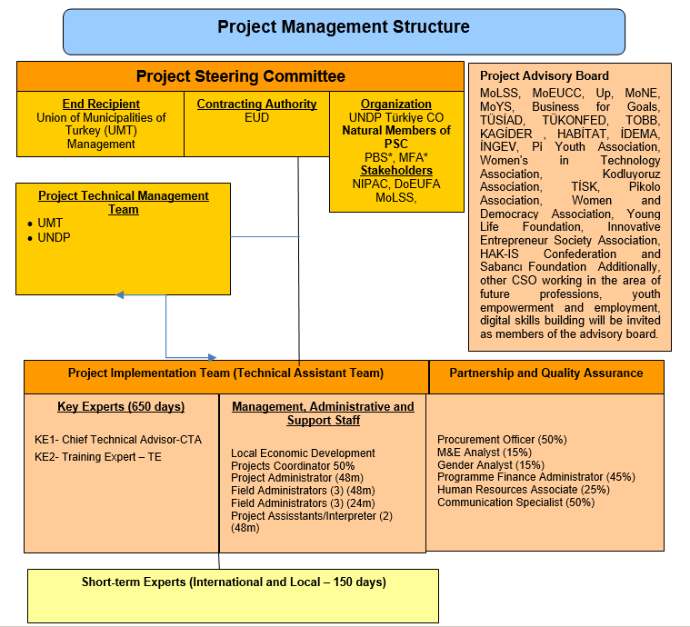
The Annual Project Steering Committee Meeting will be held to share the project progress and take the comments and the views of the committee. The last year of the project will be focusing on the monitoring and evaluation activities to ensure the created model’s sustainability and efficiency.
A baseline analysis is planned to be started in the first weeks of the project to create a basis for the activities and the impact analysis of the project.
Efficient:
The project proposal has a budget plan in detail and the LPAC found it reasonable.
Effective:
A perception analysis will be done to collect the needs and views of the youth for the project. From the name of the digi youth centers and services of the centers to what the youth understand from the future jobs will be analyzed and included in the project.
In summary, the project will carry out activities under 3 main components:
1. Establishment of Digi Youth centers with local needs and demands in line with the global agenda and with region-specific designs
2. Developing the capacities of municipalities, preparing and maintaining the business plan of digi youth centers
3. Providing trainings; The training given to the youth will be given by the trainers trained within the scope of the project. Training of trainers will be taken from experts that will be contracted in project.
Sustainability and National Ownership:
Ministry of Foreign Affairs and Presidency of strategy and Budget are the members of the LPAC. While creating the project proposal, both supply and demand sides of the employment (municipalities, youth and employers) were heard through stakeholder meetings, and their contributions and needs were included in the project.
The sustainability of the project will be ensured by a model development for the vocational education of the youth through municipalities for future jobs. Also, a digital platform will be established.

RECOMMENDATIONS:
- Adıyaman and Osmaniye that severely affected by the 6th of February 2023 earthquake can be added to the pilot provinces of the project.
- The pilot provinces of the project that affected by earthquake should be reached through online applications and mobile vehicles at the second quarter of 2023.
- Impact of the project should be assessed. Baseline studies can be started before the project launch for impact assessment analysis.

ATTACHMENTS:
- LPAC Checklist (filled-in by RBM Associate)
- Quality Assurance Report (prepared by PM or CL and approved by ARR-P)
- SESP (prepared by PM or CL)
- AWP (prepared by PM or CL)
- Risk Analysis (prepared by PM or CL)
- Capacity Assessment, if any (prepared by PM or CL)
- Micro Assessment, if any (through RBM Associate)
- Any agreements, if any
- List of participants

